吉林大学体育学院导师信息
姓名 | 王超懿 | 性别 | 女 | 出生年月 | 1985.4 | 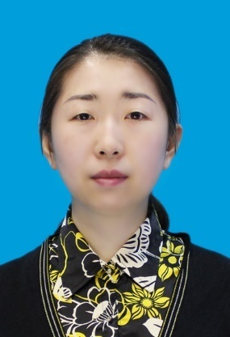  照  片
民族 | 汉 | 政治  面貌 | 群众 | 职务  职称 | 副教授
学历 | 研究生 |  | 学位 | 哲学博士
研究方向 | 运动人体科学
发表论文  及课题 | - Wang, C., & Shea, C. H. (2019). Bimanual control strategies. Quarterly Journal of Experimental Psychology, 72(4), 966–978.  - 王超懿, 邹晓峰, 朱寒笑, & Shea, C. H. (2019). 目标大小对单臂和双臂动作控制特点的影响. 天津体育学院学报, 34(3), 243–249.  - Wang, C., Kennedy, D. M., Panzer, S., & Shea, C. H. (2018). Intentional Switching Between Bimanual Coordination Patterns. Journal of Motor Behavior, 50(5), 538-556.  - Wang, C., Boyle, J. B., Dai, B., & Shea, C. H. (2017). Do accuracy requirements change bimanual and unimanual control processes similarly? Experimental Brain Research. 235，1467–1479.  - Wang, C., Kennedy, D. M., Boyle, J. B., & Shea, C. H. (2013). A guide to performing difficult bimanual coordination tasks: Just follow the yellow brick road. Experimental Brain Research, 230, 31–40.  - 混合难度系数对双臂目标互惠运动中单臂和双臂控制策略的影响， 2017QY033，吉林大学基本科研业务哲学社会科学研究项目 2 万元，2017/06-2019/07，已结题，主持
专著
获奖情况（荣誉称号） | - Outstanding Student Paper Award in the Motor Learning and Control program area (2016), North American Society for the Psychology of Sport and Physical Activity (NASPSPA) conference. （2016 北美运动心理和身体活动学会优秀学生论文奖 - 动作学习与控制领域）

